1. Create the server on openstack

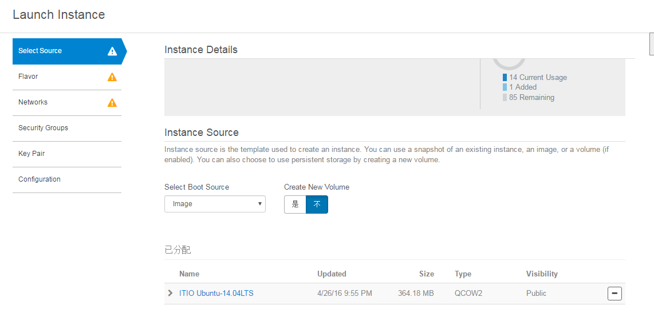

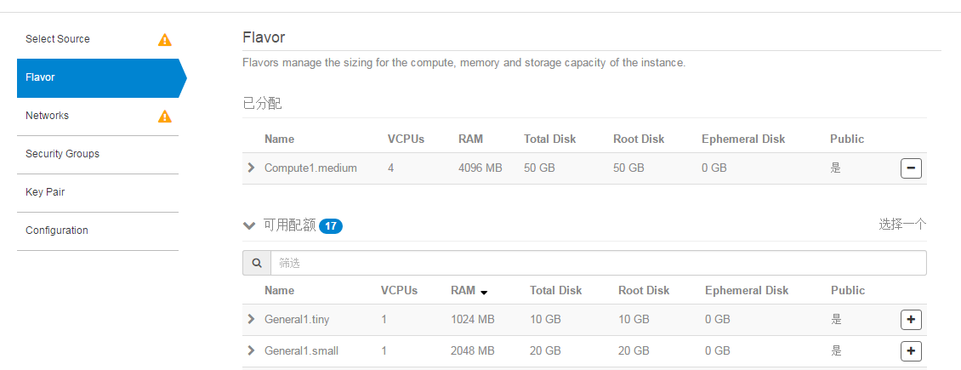

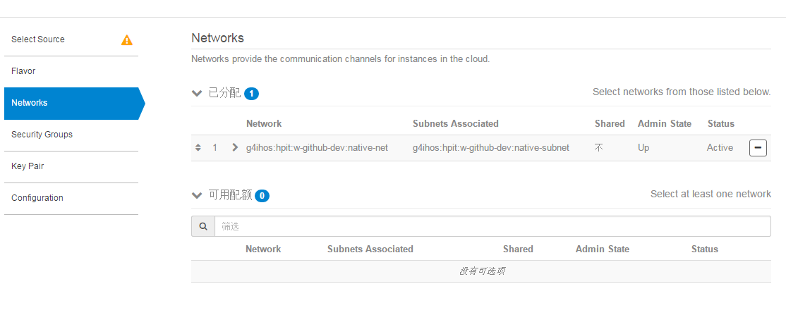you must add the ssh group, if you want to ssh to the instance.

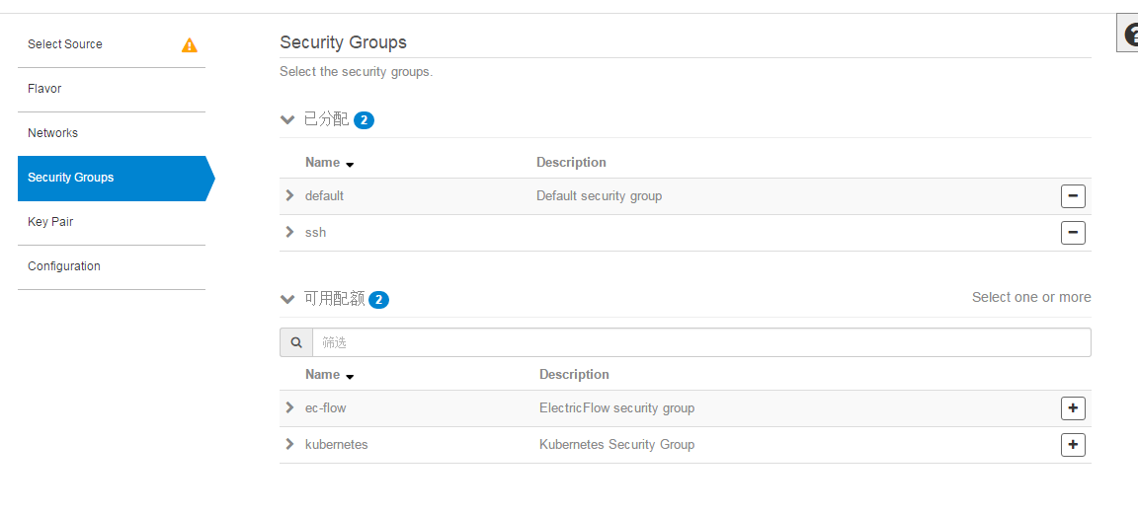

Create the new keypair for the instance

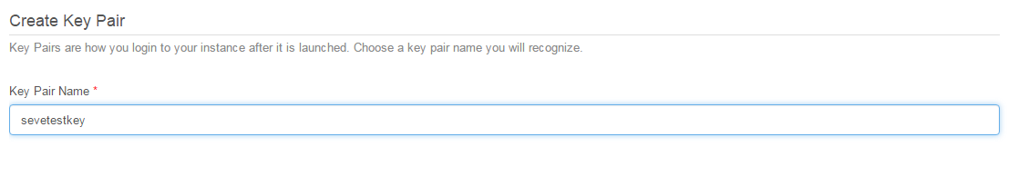

Copy the private key to a file , you can use it to connect to the instance.

At last, you can luanch it.

1. Login the server on openstack.

Use  to transformate the public key to the keyfile which putty use. Load the file that you saved last step. And 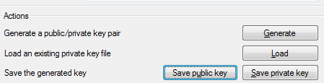

Save private key, then you can get the file.

I defined it mypulickey.ppt,

Now use it login in the instance with the key.

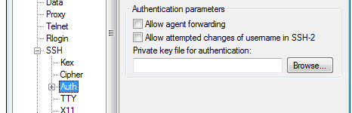

Note: login name is hos

1. Install python-openstackclient On your instance

pip install python-openstackclient

If you face the problem that you can’t find <Python.h>

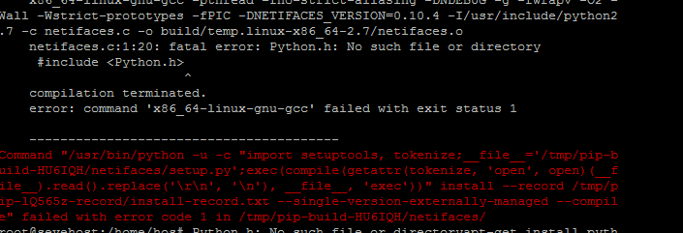

You can excute



If there need any module, pip install it

1. Nova client config

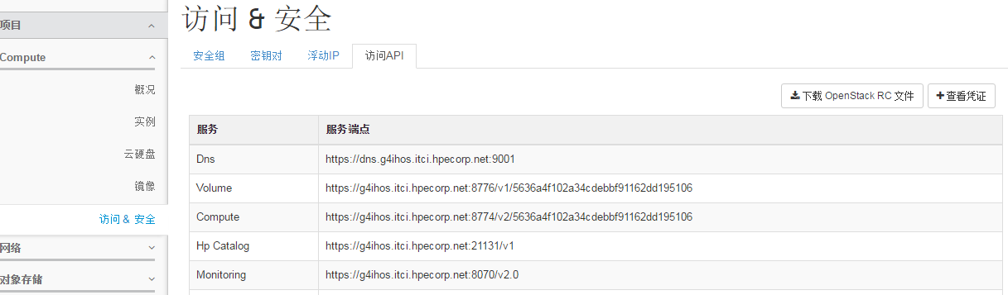

From the page , download the “open stack RC file”,

Store it on ~/opensrc

And then 

If your domain is hpe, you can Configure like this

export OS_AUTH_URL=https://g4ihos.itci.hpecorp.net:5000/v3

# With the addition of Keystone we have standardized on the term **tenant**

# as the entity that owns the resources.

#export OS_TENANT_ID=5636a4f102a34cdebbf91162dd195106

#export OS_TENANT_NAME="g4ihos:hpit:w-github-dev:native"

export OS_PROJECT_NAME="g4ihos:hpit:w-github-dev:native"

export OS_PROJECT_DOMAIN_ID="default"

# In addition to the owning entity (tenant), OpenStack stores the entity

# performing the action as the **user**.

export OS_USERNAME="li.lan@hpe.com"

export OS_USER_DOMAIN_NAME="HPE"

# With Keystone you pass the keystone password.

echo "Please enter your OpenStack Password: "

read -sr OS_PASSWORD_INPUT

export OS_PASSWORD=$OS_PASSWORD_INPUT

# If your configuration has multiple regions, we set that information here.

# OS_REGION_NAME is optional and only valid in certain environments.

#export OS_REGION_NAME="region1"

# Don't leave a blank variable, unset it if it was empty

#if [ -z "$OS_REGION_NAME" ]; then unset OS_REGION_NAME; fi

And this is important, if you want to execute a command

You need add –insecure

Like this

nova --insecure boot --key_name sevetest --flavor 1c090a98-97ec-460f-8981-e39779f50cb8 --block-device-mapping vda=3e16647e-17c0-4935-9a73-6a4d25a86aef:snap::1 --block-device-mapping vdb=6f0794b3-23bc-4e77-8d40-5fe73d92cbde:snap::1 --nic net-id=299ffd32-2b8f-449e-8f9d-4d917e67a681 --availability-zone AZ1 --security-groups="default" GHE-test